**QZ-Companion Installation**

Authors: Al Udell and Roberto Viola

June 28, 2022

QZ and QZ Companion software development: Roberto Viola

QZ on Facebook - <https://www.facebook.com/groups/149984563348738>

**Technical Overview:** The new QZ Companion app, when installed on your treadmill, communicates live speed and inclination to the QZ program running on another device (e.g. Windows PC or laptop, Android phone or tablet, or iOS iPhone or iPad). QZ then communicates this information to Zwift running on a 3rd device (e.g. Windows PC or laptop, Android phone or tablet, or iOS iPhone or iPad). A 2nd device could be used to run both QZ and Zwift, eliminating the need for a 3rd device, as long as QZ in the background while Zwift is in the foreground. This only works consistently on Windows and iOS, but not Android.

**About QZ Companion**:

* This solution works on iFit-enabled/iFit-embedded treadmills – it transmits speed and inclination directly to Zwift. What other stats are sent, can be sent, calculated, etc ...?
* The QZ Companion app always runs in the background on your treadmill, using minimal memory and CPU.
* QZ Companion will auto-start when the treadmill is powered on. There is no need to enter the treadmills “privileged mode” after initial installation.
* QZ Companion is not affected by Android or iFit updates. It continues to auto-start and run in the background after all iFit and Android updates.
* QZ Companion communicates directly with QZ, so you can use it with Zwift but also with QZs many unique features - such as ...
* You can use flexible equipment startup sequences - e.g. start your treadmill first, HRM monitor second, QZ app third, Zwift last, or change the sequence. QZ will always communicate with QZ Companion regardless of your startup sequence.
* QZ Companion is installed over Wifi via an ADB script run from a Windows PC. It makes no changes to the underlying Android or iFit structure and can be easily removed via an uninstall script or by doing a treadmill factory reset.

**Disclaimer**: I have currently only tested this solution on my NordicTrack Commercial 2950 (2021 model) treadmill with a built-in 22” touchscreen. However, it should work on any iFit-enabled/iFit-embedded NordicTrack or Pro-Form treadmill with built-in Android tablet. Refer to <https://www.ifit.com/equipment/treadmills> for more details.

Please let us know if you get this to work on your treadmill so we can compile a list of compatible machines.

NordicTrack Commercial 2950 (2021 model)

**About iFit**: To workout in Zwift, you will need to logon to iFit on your treadmill in order to use manual mode. However, you do not need an iFit subscription to use the treadmills manual mode.

**Installation Instructions:** If you have USB debugging mode enabled and know your treadmills IP, you can skip to step 4.

1. Factory reset the treadmill. It is highly recommended that you factory reset your treadmill before continuing. In my case, a reset is performed on my NT C2950 by pressing in and holding the pinhole style reset button on in the left-side on the console while simultaneously turning on the treadmill with the power switch. I use a paper-clip to push the reset button in. The reset button must be released after 10 seconds of turning the treadmill on. Unfortunately, the reset button and power switch are far apart and may require two people to coordinate the reset. After the 10 second reset, the console will display the reset and progress animation. The reset usually takes about 5 – 7 minutes on my treadmill. When it is done, iFit will prompt you do login and select your Wifi network.
2. Enable Privileged mode. When you see the main iFit dashboard screen, tap on an area of white that doesn’t activate anything (e.g. the top of the screen) 10 times, count 7 seconds, then tap on the same spot 10 more times. If done correctly, you will see the Privileged mode activation screen. Open the website https://getresponsecode.com and enter the first 6-digit code you see on your treadmill screen and click Submit. The website will provide a response code which you will enter in the treadmill console via the onscreen keyboard. If done correctly, a message at the bottom of the screen appears confirming privileged mode is enabled, and the Android desktop will appear.
3. Enable USB debugging. From the treadmills Android desktop, swipe up from the bottom of the screen to open the installed apps screen. Select Settings, System, Advanced settings, and About tablet. Take note of the treadmills IP address (e.g. 10.0.0.124), and also look for the Build number. Tap on the Build number 7 times. You will get a message at the bottom of the screen confirming Developer options is unlocked. Next, select the back button/arrow to return to the previous Advanced settings screen. Select Developer options and look for USB Debugging – turn it on. Select Ok when the ‘Enable USB debugging’ prompt appears.

Enable USB Debugging on your treadmill

1. Install the QZ Companion app on your treadmill. Download the QZ Companion installation package (qz-companion.zip) and unzip/extract it to your Windows PC. Go into the extracted folder and run qz-companion.bat by either double-clicking it or running it from the command-line. When prompted to enter the treadmills IP address, enter the same IP as noted in previous Step 3 and hit enter. The script will ping the IP address first to ensure it is reachable on the network, then proceed to open an ADB connection and install the QZ Companion app. When completed, the script will reboot the treadmill. Once rebooted, proceed to login to iFit. At this point, QZ Companion is running in the background and is ready to transmit treadmill speed and incline data to QZ.

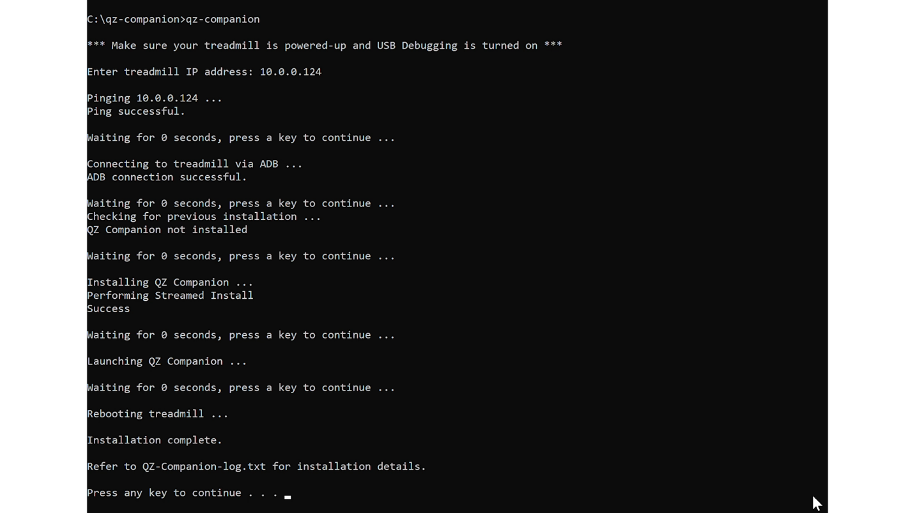

Run QZ-Companion.bat on a Wifi connected Windows PC

1. Configure QZ to communicate with QZ Companion. On your 2nd QZ device (Windows PC or laptop, Android phone or tablet, or iOS iPhone or iPad), open QZ and go to Settings. Expand Treadmill Options, Proform/NordicTrack Options, enter the treadmills IP address under NordicTrack 2950 IP and hit OK. Exit and relaunch QZ to activate the change. If done correctly, QZ will display live data tiles to indicate it is communicating directly with QZ Companion on the treadmill. Next in QZ, expand Experimental Features and turn on Enable Virtual Device, Virtual Device Bluetooth, and Wahoo Direct Connect. Exit and relaunch QZ again to activate the changes. Wahoo direct connect will now transmit the treadmills speed and incline data to Zwift via Bluetooth.

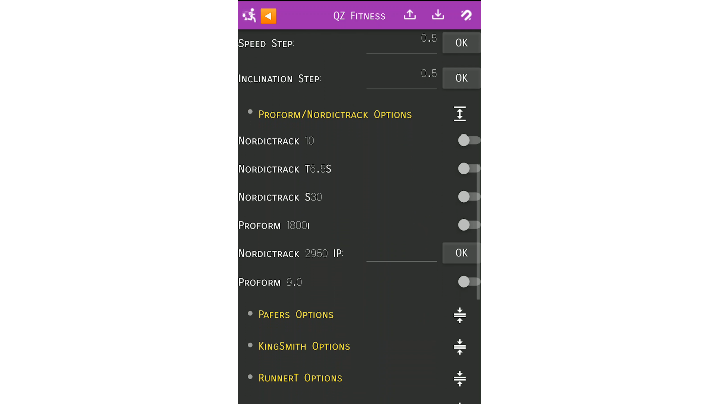

Enter your treadmill IP address in QZ

Turn on Enable Virtual Device, Virtual Device Bluetooth in QZ

Turn on Wahoo Direct Connect in QZ

1. Start an iFit manual workout to confirm QZ Companion communication. From the main iFit dashboard screen on your treadmill, select Manual workout. QZ Companion will immediately begin to transmit live speed and incline changes to QZ which will display in the live data tiles. At this point, you can take advantage of the many features of QZ while working out or simply use it to transmit data to Zwift.

Start an iFit manual workout

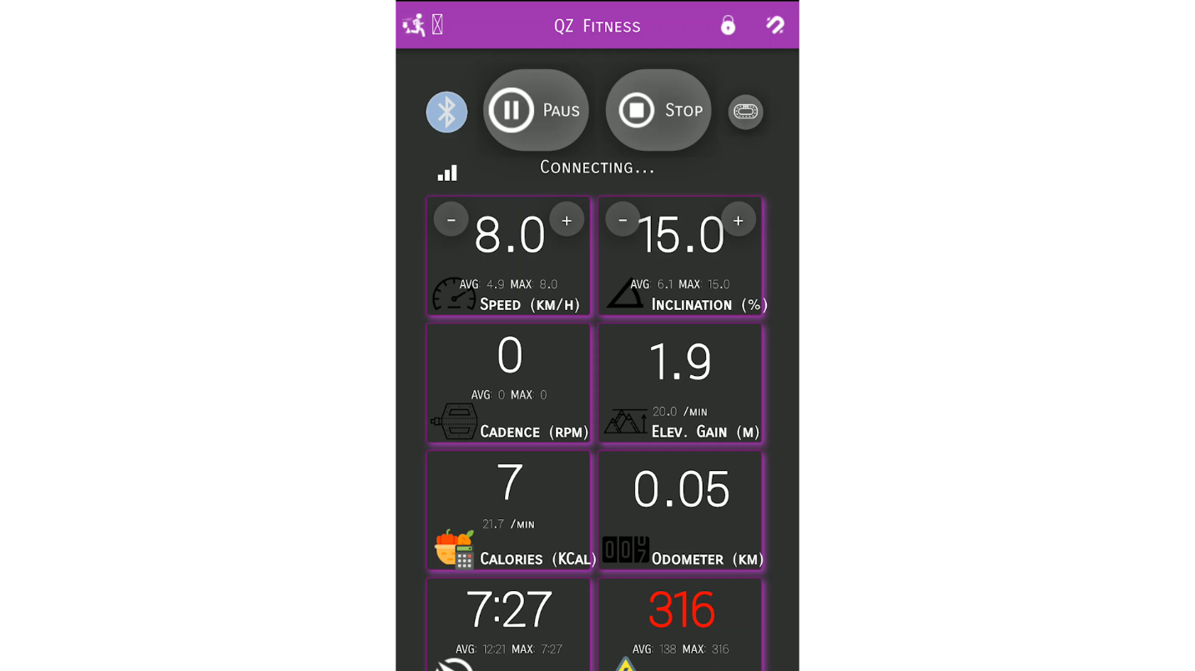

QZ receiving live speed and incline from QZ Companion

1. Finally, launch and configure Zwift to use the QZ Bluetooth device. Now that QZ is receiving live treadmill data from QZ Companion, Zwift can be configured to receive this data from QZ over Bluetooth. At the Zwift Paired Devices screen, under Run Speed, search and select Wahoo Tread device (this is QZ). Optionally select your Heart Rate and Cadence devices and proceed to start a Zwift workout. Zwift will receive live speed and incline data from your treadmill via QZ and QZ Companion data link.

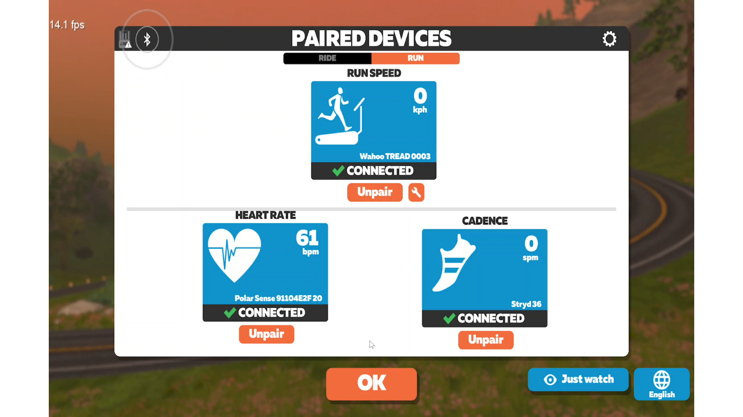

Select Wahoo Tread device as Run Device in Zwift

Start a Zwift workout and control speed from your treadmill

**The QZ Companion installation package (qz-companion.zip) contains**:

* QZCompanionNordictrackTreadmill.apk (QZ Companion Android app).
* QZ-Companion.bat (batch script used to install QZ Companion via ADB).
* QZ-Companion-simple.bat (alternative batch script to use if you wish to run the commands separately for debugging and troubleshooting purposes).
* Uninstall-QZ-Companion.bat (batch script used to uninstall/remove QZ Companion).
* QZ Companion Installation.pdf (this document)
* All other files (adb.exe, AdbWinApi.dll, tee.exe) are required for the scripts. Do not delete them).

**Troubleshooting**:

* The primary reason QZ Companion installation will likely fail is because your Windows PC can’t communicate with the treadmill IP address over your Wifi network. Ensure both devices are connected to the same Wifi network. The installation script will first attempt to ping your treadmill IP address. If this ping fails, you will need to troubleshoot the connection.
* When executed, the QZ-Companion.bat installation script will generate a log file – QZ-Companion-log.txt. If communication fails or the app fails to install on your treadmill, refer to this log to troubleshoot specific errors. You may be required to share this file to obtain technical support.